Implementation of the Stakeholder Influence Model

Graphical user interface, Application

Description generated automatically

**Problem Definition:** The Audience Monitor program uses data collection techniques in pre-determined portals to measure the level of relevance and frequency of the search term. With this tool it is possible to monitor the level of relevance a theme has on a page. Complementarily, the tool allows the creation of sentiment analysis, being able to classify the content into positive, negative and neutral. Thus, it is possible to visualize the performance of a theme in an integrated dashboard.

The types of insights we can provide you:

• We can take programmatic data, such as basic registration and attendance data that includes title, content, date, link, etc., and run it through the Audience Monitor model to reveal insights into reveals the relevance of the topic through an alert system and what you can do to address these gaps.

We leverage a statistical analysis technique that uses machine learning models to evaluate the data, extracting tags and generate sentiment analysis. Running the model on existing data allows us to make tailored recommendations to improve your programs. The types of insights we can provide you:

•Frequency of Themes: Number of times the theme appears on the defined page in terms of the day of the week and the time of day.

•Sentiment Analysis: through artificial intelligence defining the polarity of the message. Messages are classified into positive, negative and neutral.

•Source of information: Definition of the source of information and level of audience of the page.

**Database: The**  data used comes from scrapping from previously defined websites.

**Data Analysis:** The data will be analyzed in powerbi for the generation of graphs and information to characteristicize the strategic problems that should be solved.

**Data pre-processing:** Treatment of the texts collected with the transformation of the site data.

**Model Construction:**  The model will be built in supervised learning using the classification of feelings method made available by the azeure portal.

**Model Deploy:**  The model can be used in powerbi data visualization tools or Flask web application tools.

**Tools and Libraries needed:** Powerbi, Azure for sentiment analysis.

**Repository:** https://app.powerbi.com/view?r=eyJrIjoiNzk0OTNlYjMtMjVkZS00Y2M3LWE3MmMtN2VjNGYzNmIzM2Y0IiwidCI6IjE4MzNkNDljLTQzZGItNGRmYy1hNDE3LWJjMDk4YjE0OGQ2MSJ9&pageName=ReportSectiona3c0584a52c390ed7090

Creation of the Model

1. Define connection type for data fetching

Graphical user interface, Application

Description generated automatically

1. Create data connection to target web portal: https://www.centa.gob.sv/2015/page/1/?s=CRS

Graphical user interface, Text, Application, Email

Description generated automatically

1. Create data table using the examples function:

Graphical user interface, Text, Application

Description generated automatically

1. Identification of the data pattern for collection:

Graphical user interface

Description generated automatically

1. Loading the initial table that was typed. Editing in powerquery:

Text

Description generated automatically

1. Page paging parameter ID:

Text

Description generated automatically

1. Creating null query for inserting page data:

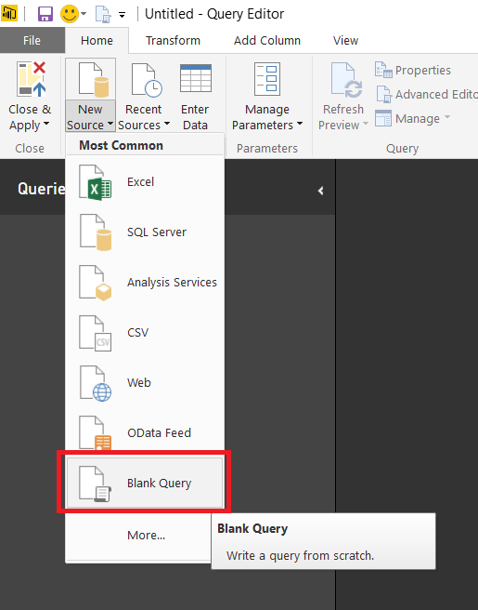

1. Creation of the Paging list.

Graphical user interface, Application, Table

Description generated automatically

1. Create Function based on the collection structure to create automatically.

Graphical user interface, Text, Application

Description generated automatically

1. Based on the list of vectors created invoke custom function:

Graphical user interface, Text, Application, Email

Description generated automatically

1. Transforming columns for data frame generation:

Table

Description generated automatically

Graphical user interface, Application

Description generated automatically

1. Creation of Query for tag generation of news texts

Graphical user interface, Text, Application

Description generated automatically

Graphical user interface, Text, Application, Email

Description generated automatically

1. Creation to generate the feeling of news texts:

Graphical user interface, Text, Application

Description generated automatically

1. Create custom column for news tag extraction:

Graphical user interface, Application

Description generated automatically

Text

Description generated automatically

1. Create custom column for news sentiment generation

Graphical user interface, Application

Description generated automatically

with average trust

1. Generation of the final model data frame

